Homework 9
- All homework must be turned in on PDF format. This can be scanned or typed in any paper size, but the format must be PDF and the file must be readable. This document can be modified for your homework submission. An additional homework template is available on Canvas to assist you in creating your answers, and content from lecture notes can be used.
- All final answers must be circled or in green.
- All homework must have a name on the top of every page.
- Submission errors (not in PDF, illegible, etc.) will not be re-graded.

Problem 1 (1 point each)
Construct state diagrams for the following:
  - D flip-flop
  - T flip-flop
  - JK flip-flop

Problem 2 (3 points)
Using the timing diagram with inputs below, fill in outputs for the circuit given below.

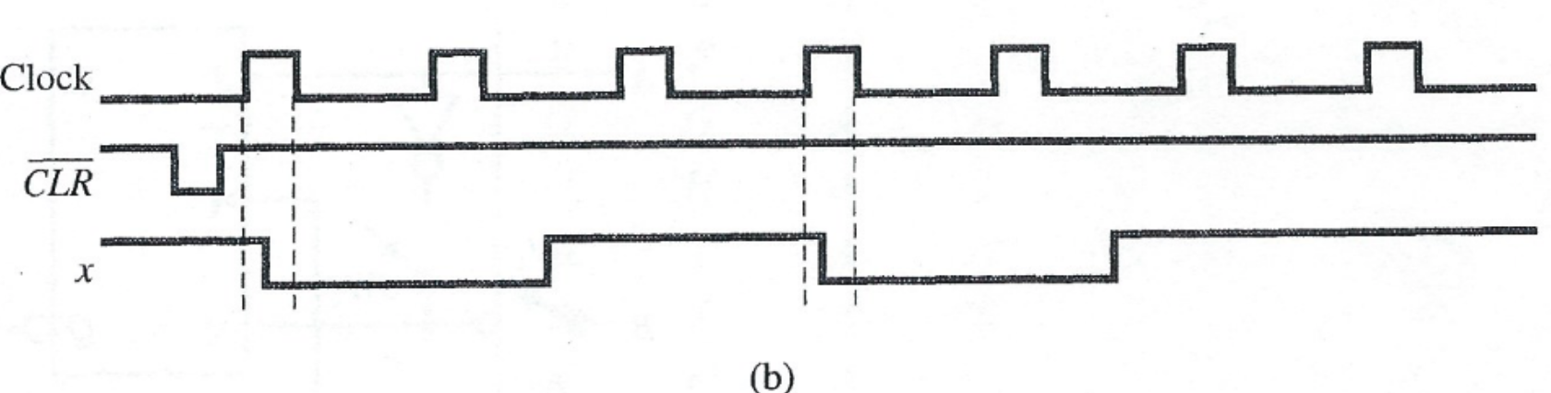

Problem 3 (1 point)
Construct a D flip-flop using only a JK flip-flop and a minimal number of gates.

Problem 4 (3 points)
For the following circuit, complete a timing diagram where the values x = 011100010 are captured and $y_{1}(t=0)= y_{2}(t=0) = 0$.
